**HTML | <iframe> name Attribute**

Last Updated : 22 Jul, 2022

The **HTML iframe name Attribute**is used to specify a reference for an **<Iframe>**Element. The name attribute is also used as a reference to the elements in a Javascript.

**Syntax:**

<iframe name="name">

**Attribute Values:**

* **name:**It specify the name for the Iframe element.

**Example:**

**html**

|  |
| --- |
| <!DOCTYPE html>  <html>    <head>      <style>          body {              text-align: center;          }      </style>  </head>    <body>      <h1 style="color:green">        GeeksforGeeks    </h1>      <h2>        HTML &lt;Iframe&gt;name Attribute    </h2>      <p>Content goes here</p>        <iframe src=""              height="200"              width="200"              name="myGeeks">      </iframe>      <br>      <a href="[https://ide.geeksforgeeks.org/"](https://ide.geeksforgeeks.org/%22)         target="myGeeks">        GeeksforGeeks    </a>        <p>Content goes here</p>    </body>    </html> |

**Output:**

**Before:**

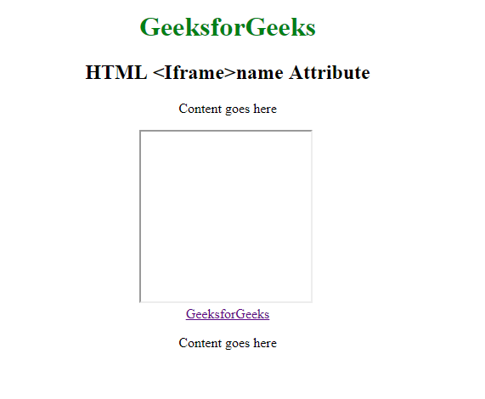

**After:**

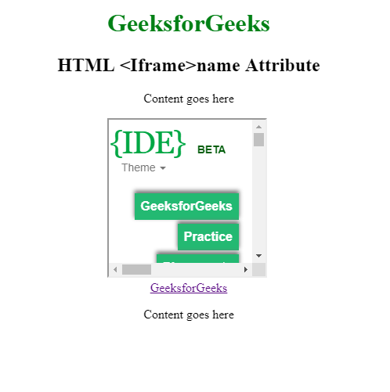

**Supported Browsers:** The browsers supported by **HTML <iframe> name Attribute** are listed below:

* Google Chrome 1 and above
* Edge 12 and above
* Internet Explorer
* Firefox
* Apple Safari
* Opera

Dive deep into the world of JavaScript with our [JavaScript Full Course Online](https://www.geeksforgeeks.org/courses/javascript?utm_campaign=three_90_345_abt&utm_medium=gfgcontent_abt&utm_source=geeksforgeeks), offering everything from the basics to advanced techniques. Learn how to build interactive websites, optimize your code, and earn a certification to showcase your skills.  
  
Take the **Three 90 Challenge**! Complete **90% of the course** in **90 days**, and **earn a 90% refund**. Push your limits and stay motivated as you work towards mastering JavaScript. Join now and get started on your **JavaScript learning journey!**

Comment

More info

[Advertise with us](https://www.geeksforgeeks.org/about/contact-us/?listicles)

[**Next Article**](https://www.geeksforgeeks.org/html-iframe-referrerpolicy-attribute/?ref=next_article)

[HTML <iframe> referrerpolicy Attribute](https://www.geeksforgeeks.org/html-iframe-referrerpolicy-attribute/?ref=next_article)

**Similar Reads**